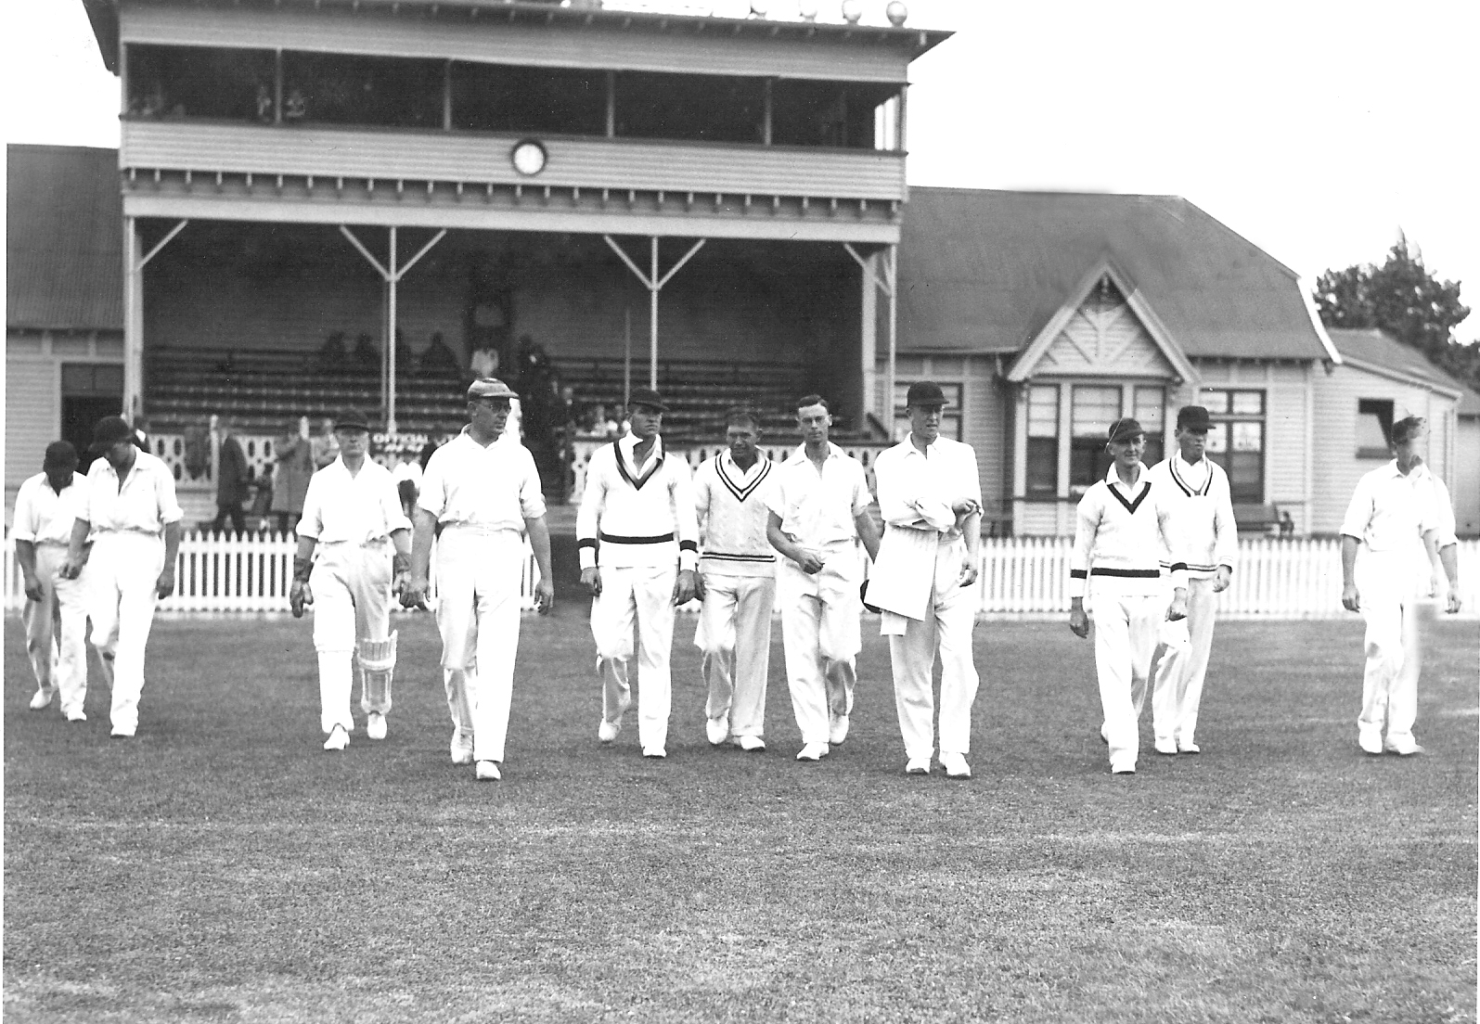

**Ian Cromb leading the Canterbury team out prior to the match against Otago 14 February 1936**

Otago 173&150 Canterbury 174 &230. Canterbury lost by 119 runs